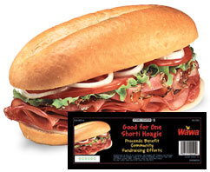
Great Valley Music Parents Association - Student Fundraiser

WAWA Shorti Hoagie Coupons Order Sheet
$4 per coupon
Name | #  Shorti  Coupons | Total  Due  (# x $4.00) | Total  Collected

Please drop off a sealed envelope with completed order form and full payment to the drop box outside of the Music office, or mail to GVMPA, PO Box 955, Frazer, PA 19355. Orders processed as received, while supplies last. Checks made payable to GVMPA

Student Name: _________________________________________________________
Phone: _______________________________________________________
Email: _________________________________________ (for questions about your order)
*** Please keep a copy of this order form for your records ***
See separate page for fundraising details.

